**Software Requirements**

**Specification**

**for**

**Online homemade food catering system**

**Prepared by**

* **Sayra,Efat 19-40475-1**
* **Md Tamim Ul Islam 19-40902-2**
* **Sourov,Shahriar Hossen 19-40848-2**
* **Jeba Fawjia 19-39815-1**
* **Iffat Sohana Niha 19-40473-1**
* **Sumaia Mahmuda 19-41622-3**

***.***  **American International University-Bangladesh 2022-12-11**

***Copyright © 1999 by Karl E. Wiegers. Permission is granted to use, modify, and distribute this document.***

***PROJECT REPORT BRIEF***

**Problem statement:**

In today’s world the number of jobs is decreasing on the other hand day to day life expenses for a family is increasing rapidly. In this situation it is becoming hard for the families where only one person had job. As a result it’s becoming herd for him/her to carry his/her family. There are some people in almost every family know how to cook very well and they are cooking food for their family. They got the potential to cook for more people. Some of them knows how to cook different different types of healthy and tasty homemade foods item those are not available in the outside in any restaurants because those are local foods and only local household people can prepare that perfectly.

On the other hand some job holders or students live in the city without his/her family and from their perspective it become hard for them to continue their work and cook at the same time. They can’t even go to restaurants every single day as they are much more expensive. As a result they rarely find a good and healthy food options for them.

So there are potential persons who can make homemade food and carry some of the expenses of their family. And there are also people who want tasty and healthy homemade food items.

**Existing solution:**

At this point, people have two choices-either search the entire city for good and cheap restaurants where local food is the main items or keep eating rich foods regularly. Either of them is not a sustainable option. There are some other apps for food service but maximum of them are based on restaurant and they serves restaurant food to the people through the system and they are quite expensive and maximum people can’t afford them every single day. On the other hand people also could manage their food by going to market every day to buy food items then cook them and finally they can have that. But when it is about a single person living in the city or family where every single person works in different place then it is quite hard for them to manage time to go to market to buy items and then cook them. For this reason people always look for a better option to buy healthy and cheapest food items.

**Proposed solution:**

Nowadays homemade food is rear in every restaurant. There are a few restaurants in every city and county that will provide homemade food. Every restaurant provides fast food and junk food which is very harmful to human health. Such risks include obesity, insulin resistance, type 2 diabetes, and various cardiovascular conditions. This is because most fast food is high in sugar, salt, saturated fat, trans fats, processed ingredients, and calories. It is also generally low in antioxidants, fiber, and many other nutrients. Home food catering will provide high-quality meals and fresh, top-notch products in order to gratify their consumers. Aside from bringing people together, there are numerous more advantages of cooking at home. The points which are mentioned above are some of the most compelling reasons to include more homemade foods in the diet. Homemade food is cheaper than processed food. This homemade food is also available in every local area which will helps the customers to enjoy homemade food. When customers orders to prepare their own meals, they have more control over the ingredients. This can help you to look and feel healthier, boost energy, stabilize weight and mood, and improve your sleep and resilience to stress.

# Table of Contents

Table of Contents 4

Revision History 5

1. Introduction 1

1.1 Purpose 1

1.2 Document Conventions 1

1.3 Intended Audience and Reading Suggestions 1

1.4 Product Scope 2

2. Overall Description 3

2.1 Product Perspective 3

2.2 Product Functions 4

2.3 User Classes and Characteristics 5

2.4 Operating Environment 6

2.5 Design and Implementation Constraints 6

2.6 User Documentation 6

2.7 Assumptions and Dependencies 6

3. External Interface Requirements 7

3.1 User Interfaces 7

3.2 Hardware Interfaces 10

3.3 Software Interfaces 10

3.4 Communications Interfaces 11

**4. System Features 15**

4.1. User Account Registration 12

4.2. User Edit Profile 13

**5. Other Nonfunctional Requirements 15**

5.1. Performance Requirements 15

5.2. Safety Requirements 15

5.3. Security Requirements 16

5.4. Software Quality Attributes 16

5.5. Business Rules 17

6. Other Requirements: 18

# Revision History

|  |  |  |  |
| --- | --- | --- | --- |
| **Name** | **Date** | **Reason For Changes** | **Version** |
| First Draft | 2022-12-12 | Initial version draft sent out for comments | Version 0.1 |
|  |  |  |  |

# 1. Introduction

## 1.1 Purpose

Our project's primary goal is to create a digital homemade food court. Customers can swiftly and conveniently place their food orders. Orders are also received by food page owners, who then prepare them their ordered meal. Home delivery is an option for customers. There will be also chance for picking up the food from a specific place given by the owner. Each restaurant owner can manage their restaurant and business easily with the software. Last but not least, digitizing this system frees up a ton of time so that individuals can use.

## 1.2 Document Conventions

Bold type is used to highlight defined keywords. Priority will be assigned to requirements to show how they will be implemented. Versions with partial implementations of any or the entire whole list of requirements may be released.

## 1.3 Intended Audience and Reading Suggestions

To explain the purpose and appearance of the software, this paper is intended for the Software Designers then software developers and also QA engineers. Other than them it is also for the investors and the people who are active in managements and decision making on behalf of the Software farm. The software's administrators will have access to carry out unique and specialized tasks with a less obvious user interface.

Readers are suggested to read the document from the beginning and follow the highlighted parts to understand the description topics. Important lines are also highlighted. If there is any problem of understanding or there is any unwanted mistake then readers are encouraged to contact the contributors of the report.

This is a list of those who contributed to this report. This mailing group will be sent the draft for feedback and input.

|  |  |
| --- | --- |
| Efat Sayra | Sayraw@Gmail.Com |
| Md Tamim Ul Islam | Tamimislam@Gmail.Com |
| Shahriar Hossen Sourov | Sourov.10799@Gmail.Com |
| Sumaia Mahmuda | Sumaiamahmuda1999@Gmail.Com |
| Iffat Sohana Niha | Nihauni@Gmail.Com |
| Jeba fawjia | fawjiazeba@gmail.com |

## 1.4 Product Scope

Project scope is how we are going to get our goals. Our system will be used by 3 main actors which are customer, Food shop owners and delivery guy. For our system, project scopes are given below.

Customer:

1. Customers have to register and log in to update their information.
2. Customers can choose their meal from the menu
3. Customer can choose to pick up or delivery in front of the door but they have to pay cash on delivery only.
4. Customer can review their order before confirming their order.

Food Shop owner:

1. Owners have to login as shop owners every time they want to login.
2. Owner will be able to add or update food menus every day to attract customer’s attention.
3. Owner will also be able to delete the menus if there occurs any change.
4. Owners have to update the orders from customer to delivery persons in charge.
5. Owners will alter menu options to keep the foodies hooked.
6. Owners have to allow the customer to browse the upcoming menu options along with current day menu.

Delivery person:

1. Delivery guy have to login as delivery person in charge.
2. Having part time delivery guy who deliver meals to customers.
3. Delivery guy get the order list from the customer every time admin updates the order status.

# 2. Overall Description

## 2.1 Product Perspective

“Home Food Catering system” is a new application of food service but similar applications do exist in this sector. Among them ‘Food panda’ is renowned and popular within the users. But this ‘Home Food Catering system’ is mostly for house hold persons who want to start homemade food service business. This specific thing separates this system from the other similar applications. The “Home Food Catering system” provides an outstanding way of bringing home made food sellers and customers on an online platform to sell and make purchase in an effective and secured manner without any hassle and get the delivery easily without visiting anywhere. This system will be a one stop service for customers to choose and purchase from hundreds of local homemade food item nearby. The sellers will upload his/her home-made food item’s list and customer browse from these items and purchase them. This will provide an easy access to the system and it will contain user friendly functions and attractive user interface.

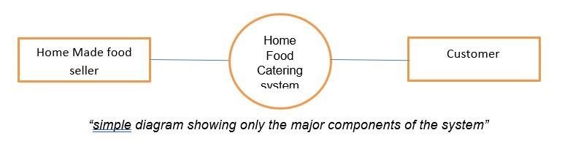

## 2.2 Product Functions

* Sign Up page. (For Joining the system)
* Sign In page. (Logging into the system)

• Sign Out. (Logging Out from the system)

• Menu card.

* Add to Menu .(For seller)
* Edit Profile. (For All user) • Edit Location. (For All user)
* Add to Cart.
* Add discount coupon.
* Confirm Order.
* Customized Order.
* Book Order.
* Contact Seller/Customer/Delivery Person.
* Track Order.
* Customer Review.
* Online Payment.

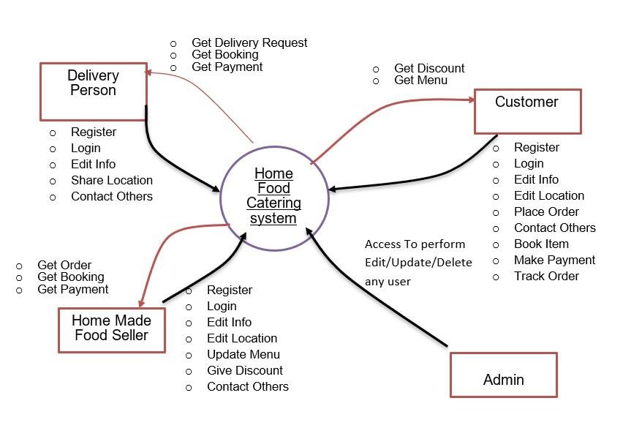

## 2.3 User Classes and Characteristics

##### 2.3.1 User Classes

1. Home Made Food Seller.
2. Shop Owner.
3. Customer.
4. Admin
5. Rider/Delivery Person.

##### 2.3.2 Characteristics of User Classes

##### 

Admin: There will be some registered Admin in the system. Admin will monitor the system and they have the access for any changes in the system and they will get the access of update, edit info of any user and also terminating any user from the system because of any occurrence or special case. Other type of user can contact them and share their problems and they will serve them.

Homemade Food Seller: Person who want to made homemade food items and sell them, can join in the system as homemade food seller. He/She can join the system easily by completing a simple registration process. After that they can log in to the system. Then they can update the menu items that they want to sell through the system. By sharing food item and location, any homemade food seller can sell their food locally. They can also give discount, take customized order (if they want), contact with the customer and delivery person.

Customer: Customer can join to the system by registration process and after that they can login to the system. Customer can see the local homemade food as well as local small restaurants. Customer can access the menu and they can place their order from that. They can also get and add any discount offers while placing the order. Customers will also be able to give customized order and book any items. Customer can change their location and other information’s when they need. Customer will be able to contact with rider and seller.

Rider/Delivery Person: Any person who wants to join the team as a delivery person can also be a part of the system. They will also register and login to the system. Then they will get offer for delivery any item nearby. They can accept or reject any delivery. They can contact with the customer as well as the seller.

Shop Owner: Any small restaurant can also be a part of the system with homemade food sellers.

They will also get all the facility that the home-made food sellers get. They can also register into the system separately. Then they can sell their items through orders, customized orders and bookings just like a homemade food seller.

## 2.4 Operating Environment

There are two modes of using the software-mobile applications and web applications. Mobile apps can be run on any android, iOS versions. Web applications can be run on Windows10: Google Chrome(78andlater); Mozilla Firefox(70andlater); Internet Explorer(11andlater); Microsoft Edge(18.18362andlater), Mac OS X: Apple Safari(13.0.1andlater). The Internet is a basic necessity for the system to be accessed.

## 2.5 Design and Implementation Constraints

## For Avoiding any kind of mismanagement system will show the food items only when the seller approve that at the beginning of the day. Otherwise it may create problem when the customer made order but food is out of stock. Also system will ask for confirmation for every order from the seller. For ease of maintenance, the customer will only be able to make payments once items have been added to cart. There is no option to proceed directly to checkout with an empty cart. And when it is about online payment the system will confirm the order only if the payment has been fully completed. Brand specific agendas have been excluded from our design. For avoiding problem customer may not edit order after confirming order. In this case they might order other items separately. Customer can not directly cancel order, in this case they might wait for the customer care call and show a valid reason for cancelling the order. If the order canceled then the online payment of the customer will not be sent back. Instead of that they might use that for future orders.

## 2.6 User Documentation

Following user documentation components will be provided:

* User manuals for food makers.
* Short tutorial clips for customers and food makers.

(Clips will be showing how to use each and every features of the system in details.)

* User guide pamphlet for customers.

## 2.7 Assumptions and Dependencies

The SRS assumes that none of the constituent system components will be implemented as embedded applications. It is further assumed that tablet PCs of sufficient processing capability and battery life will be utilized. The meal prices can be change according to meal Stock Price. The catering system is open for breakfast, lunch, and dinner every company business day in which employees are expected to be on site.

# 3. External Interface Requirements

## 3.1 User Interfaces

There are three separate user interfaces used by this software, each related to an interfaced physical hardware device. These three user interfaces are the Surface Computer UI Tablet UI and Display UI.

### Surface computer UI

User Interface Design is concerned with the interaction between a user and a computer. It covers everything from starting the system to logging in to the final presentation of essential inputs and results. The whole flow of screens and communications is referred to as a dialogue. The following are some guidelines that will be followed while designing a user’s interface:

1. The system's user should always be aware of what to do next.
2. The screen should be set up so that various types of data, instructions, and messages are always presented in the same general area.
3. Messages, instructions, and other information should be given for the system user to read for a sufficient amount of time.
4. Don't employ display features excessively.
5. User-enterable fields and answers should have default values.
6. If a mistake is found, the user should not be allowed to continue.
7. The system user should never see an operating system notice or a fatal error.

### Tablet UI

The Tablet UI is designed to run on a small, wireless-enabled touch-screen tablet PC, to be used by waiters to accommodate customer needs. This UI will be designed for use with a stylus input into the touch-screen. Because the number of operations the UI needs to support is relatively limited, there will be no nested menu structure. The UI shall provide simple graphical interfaces, similar to a map, to allow the user to select tables/customers as the target of operations

#### Display UI

The Display UI provides kitchen staff with simple functionality related to ordered items. The UI will display the list of items in large, easy-to-read text, sorted by time of submission with additional information (such as dietary requirements and the destination table) displayed in tabulated format. Input is provided by fingertips, as opposed to a stylus.

**User Interface for different pages:**

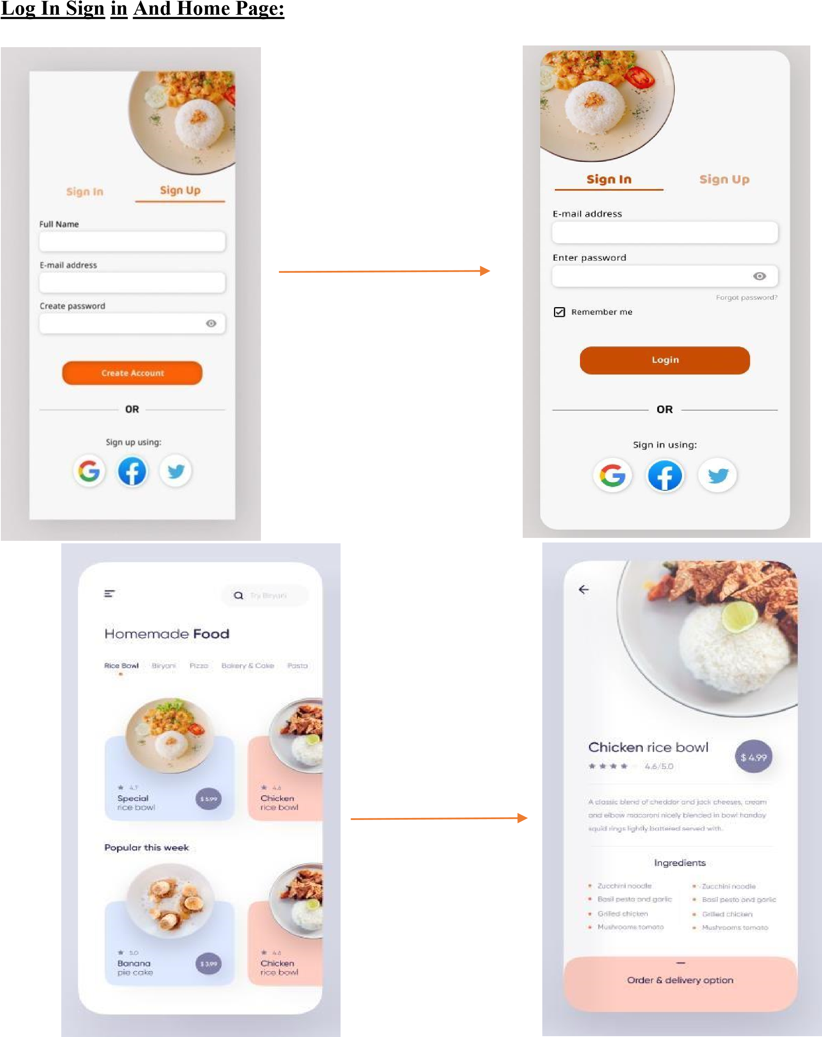

**Order Process Pages:**

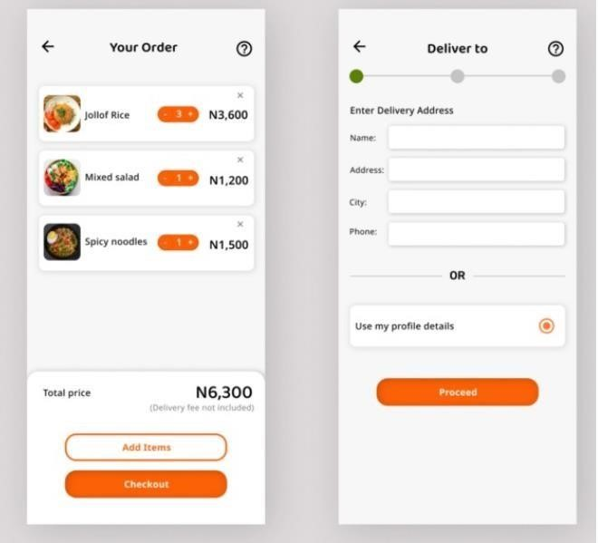

**Order Confirmation and payment Process pages:**

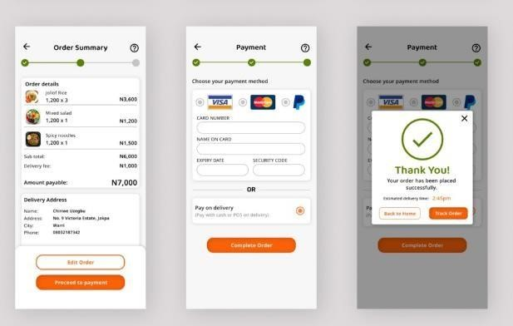

## 3.2 Hardware Interfaces

All hardware needed to connect to the internet will serve as the system's hardware interface because the program must execute over the internet. Modem, WAN-LAN, and Ethernet Cross-Cable are a few examples to be used. The system shall use the HTTP protocol for communication over the internet and the internet. Supported devices are to be a mobile, computer or another supported electronic device on which users are authorized to operate the Application. Also, there is a server side and client-side requirements for the hardware interface: a) Server side

The web application will be hosted on a web server that is listening on the web standard port, port 80.

b) Client side

Monitor screen – the software shall display information to the user via the monitor screen Mouse – the software shall interact with the movement of the mouse and the mouse buttons. The mouse shall activate areas for data input, command buttons and select options from menus. Keyboard – the software shall interact with the keystrokes of the keyboard. The keyboard will input data into the active area of the database.

Since neither the mobile application nor the web portal has any designated hardware, it does not have any direct hardware interfaces.

## 3.3 Software Interfaces

The mobile application interacts with the GPS application to obtain geographic data about the user's location and with the database to obtain information about the restaurants. The communication between the database and the web portal consists of operations concerning both reading and modifying the data, while the communication between the database and the mobile application consists of only reading operations.

* The system must communicate with the Configurator to learn about all the components that can be used to customize the product.
* In order to locate accepted payment options, verify payments, and complete payments, the system must communicate with the payment method system.
* For the purpose of managing financing options, the system must interact with the credit management system.
* In order to provide support, the system must communicate with the CRM system.
* For order management, the system must interact with the sales system.
* For order tracking and shipping method updates, the system must communicate with the shipping system.
* For the purpose of computing tax, the system must interact with an external tax system.
* For the system to validate export regulations, communication with the export regulation system is required.
* The system shall allow the users to complete secured transactions. Typically, this will be the third-party software program that is usually utilized for online transactions.

Also, there is a server-side and client-side requirement for the Software interface:

a) Server side

* An Apache web server will accept all requests from the client and forward them accordingly. A database will be hosted centrally using MySQL.
* The application programs make use of the Windows, Linux and ubuntu operating systems by making requests for services through a defined application program interface (API).

b) Client side

An OS which is capable of running a modern web browser that supports JavaScript and HTML5, Laravel frameworks and reactJS libraries which are developed in the software.

## 3.4 Communications Interfaces

Communication between the different parts of the system is important since they depend on each other. However, in what way the communication is achieved is not important for the system and is therefore handled by the underlying operating systems for both the mobile application and the web portal.

Communication protocols allow different network devices to communicate with each other. They are used in both analog and digital communications and can be used for important processes, ranging from transferring files between devices to accessing the internet. The HTPP or HTTPS protocol(s) will be used to facilitate communication between the client and server. The system shall use the HTTP protocol for communication over the internet and the internet communication will be through TCP/IP protocol suite. The system can be configured to be accessed via any available port. The only medium of communication between the user and the system is the web-based user interface. All widely used web browsers that work with JSP and HTML pages can access the system.

**communications functions requirements**:

* Web Browser: Firefox, chrome, Microsoft edge
* Communication protocols/ standards: HTPP or HTTPS and TCP/IP protocol suite
* E-mail authentication **communication security or encryption issues:**
* Line security protects communications lines of IT systems, such as a central computer and remote terminals.
* Unauthorized access prevention.

**data transfer rate:**

1. rabits per second (Tb/s) through optical fibers.

1. **System Features**

The system features are typically presented as tables of certain metrics that the system must meet in order to be accepted, in contrast to the functional requirements, which are typically descriptive in nature.

Reliability, availability, serviceability, security, scalability, and maintainability were among its components.

## User Account Registration

* + 1. Description & Priority: All of the users including -Customer and Home Made food seller, Delivery Person everyone will be able to use this features. Without account, any user will have only browsing permissions from the home page and do not have options to purchase or list goods on the system.

Accounts will hold information about name, email id or phone number, password and maybe address.

Priority level: High.

* + 1. Stimulus/Response Sequences

It will begin when the user press the Sign in, then they had to give some of their information’s including Name, Email, Mobile, Address etc. They also need to fill whether they want to join the system as a customer or seller or a delivery person. After this they will get a OTP through their email or mobile number, when they fill the correct OTP from the email or the mobile number then they will be asked to set a permanent password to login to the system. When they set that they will be automatically registered into the system. After that they can Login with their email and password.

Response sequence with the help of a sequence diagram.

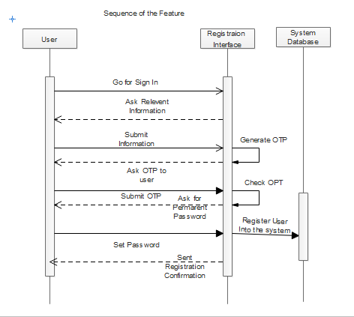

* + 1. Functional Requirements

In the User Account Registration functional requirements would be,

REQ-1: User had to submit relevant user information such as name, email mobile number etc.

REQ-2: Verify the user by sending OTP in the submitted Email/Mobile that the user added.

REQ-3: Take a permanent password from the user and then and set that into the system with the info of that specific user so that they can login to the system easily in future.

## User Edit Profile

* + 1. **Description and Priority**

This feature is applicable for the all of the users including customer, seller, admin, rider. With the Update Profile feature, the users can update their name, phone, address, user profile picture, etc which will be necessary for further updates after the registration. This feature will be enabled after the user registration. Without registration, this feature will not be enabled. The user edit profile feature can help to add any further data and correction of the information.

Priority level: High

* + 1. **Stimulus/Response Sequences**

In the first step, the user must complete the registration. After completing registration, the user requests the edit profile by redirecting to the edit profile page. After that, the user must enter accurate or valid information into the input field such as name, email, phone and password. The verification occurred in the system for updating the information. After a successful update of user information by checking verification and modification, a confirmation message will show to the user.

Response Sequences using the sequence diagram for the user edit profile features are given below-

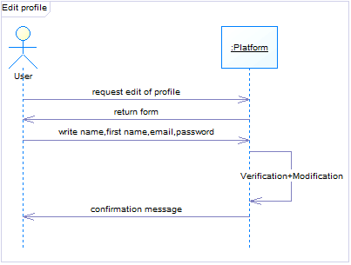

**4.1.3 Functional Requirements**

In the user edit profile, the functional requirements will be-

REQ-1: The user must complete the registration. Without completing the registration, this feature will not be enabled.

REQ-2: After registration, for editing or updating information, the user has to go to the edit profile page.

REQ-3: The user must put the correct or valid information into the input field. If the user puts any invalid data into the input field or without editing any data click on the “Edit profile” button and an error message will show to the user.

REQ-4: After editing or adding data into the input field, user must be click on the “Edit profile” button.

REQ-4: After editing data “Information updated successfully” message will show.

## Other Nonfunctional Requirements

## Performance Requirements

Table 5.1. lists the non-functional performance requirements that have been determined and are pertinent to the project.

|  |  |
| --- | --- |
| Requirement | Description |
| PR-10 | The server shall  be able to support at least 500 connections at once from any variety of tablets, surface pcs, and screens. |
| PR-11 | The server shall be able to support an unlimited number of tablets, surface pcs, and screens, i.e., this should impose no restrictions on the number of gadgets that can be used simultaneously. |
| PR-12 | The server shall be able to serve an indefinite number of active meals or orders ; in other words, no active meals or orders should be lost. |
| PR-13 | The server shall be able to serve an indefinite number of payments for active meals or orders ; in other words, any kind of payment should not be lost |

## Safety Requirements

Table 5.2. lists the non-functional performance requirements that have been determined and are pertinent to the project.

|  |  |
| --- | --- |
| Requirement | Description |
| FS-11 | The system shall log every state and state change of every kind of devices the system may run on to provide system failure recovery. |
| FS-12 | The system shall be able to revert to its original state if something goes wrong (for example- a system crash or power loss). |
| FS-13 | The system shall make use of periodic 30-second keep-alive messages between  devices and the server to monitor device’s operational status. |

## 

## Security Requirements

Table 5.3. lists the non-functional performance requirements that have been determined and are pertinent to the project.

|  |  |
| --- | --- |
| Requirement | Description |
| OS-12 | The system, at any time, should be accessed only by the authenticated users. |
| 0S-13 | The system is required to end the session automatically, when an open session is not used for a specific period of time. |

## 

## Software Quality Attributes

* + 1. **Maintainability**

The system should be simple to use for all parties involved, including users who use it regularly, developers who want to make changes or expand on it, and maintenance staff.

* + 1. **Portability**

The system should support updates to the relevant browsers. The webserver and operational technologies should be universal and available on the majority of platforms.

* + 1. **Usability**

The server should be loaded with easily navigable and usable GUI for users with any level of computer competence. All pages should include an inbuilt help feature to direct consumers through the options provided on that page. There should be clear documentation included with the system. The system should support multiple languages.

* + 1. **Availability**

The system should be available on the 24/7 to serve the customers who are doing advance reservations for customized orders.

## Business Rules

|  |  |  |  |  |
| --- | --- | --- | --- | --- |
| ID | Rule definition | Type of rule | Static or Dynamic | Source |
| Or-10 | Delivery must be completed between 9.00 am- 11.59 pm | Constraint | Dynamic | Marketing Policy |
| Br-12 | Order price is calculated as the sum of each food item price times the quantity of that food item ordered ,plus applicable VAT and a delivery charge if a meal is delivered without a free delivery discount. | Computation | Dynamic | Corporate Pricing Policy |
| CO-13 | If a customer ordered a meal from a specific seller, then offer the customer with other meals that are offered by the seller to the customer before completing the order | Action enabler | Static | Marketing Policy |
| FA-11 | Each customer must assign one and only discount or voucher to an order | Fact | Dynamic | Corporate Pricing Policy |

# Other Requirements:

Database requirement:

* The database must be able to store customer information, including login credentials, personal details and order history.
* The database must be able to store homemade food provider information, including menus, pricing, and availability.
* The database must be able to store order information, including the items ordered, the quantity, the delivery location, and the status of the order.
* The database must be able to store payment information, including the payment method, the amount paid, and the transaction details.
* The database must be able to store data related to user interactions with the system, such as browsing history and search queries.
* The database must be secure and protect customer and provider data from unauthorized access.
* The database must be scalable and able to support a large number of customers and providers

Initialization requirements:

* A list of user requirements, such as the ability to browse and select items from a menu, place and track orders, and make payments online.
* A description of the functional and non-functional requirements for the system, such as performance, security, and reliability requirements.
* A list of technical requirements, such as the hardware and software needed to run the system, and any necessary integrations with other systems or platforms.
* A description of the testing and validation process that will be used to ensure the system meets the specified requirements.

Legal requirements:

* Compliance with food safety regulations, such as the requirement to store and transport food at safe temperatures.
* Compliance with labeling and packaging regulations, such as the requirement to include allergen information on food labels.
* Compliance with data protection and privacy regulations, such as the requirement to protect the personal and financial information of users.
* Compliance with consumer protection laws, such as the requirement to provide accurate information about the food being sold and to offer refunds or replacements for defective or spoiled items.

Reuse objectives:

* Using existing components or modules for common functionality, such as user authentication, payment processing, and order tracking
* Reusing code from previous projects or open-source libraries to reduce development time and costs
* Designing the system to be modular and flexible, so that it can easily be integrated with other systems or adapted to support new features or functionality
* Developing the system using open standards and APIs, to promote interoperability and enable third-party developers to build on or extend the system

Thank You